**Name: NEHA ANTONY**

**Roll No: 23**

**Batch:MCA-B**

**Date:28-03-2022**

**NETWORKING & SYSTEM ADMINISTRATION LAB**

**Experiment No.: 2**

**Aim**

Familiarization of the linux commands.

**Procedure**

1. cat -n

Used to display the content of the file with line numbers.

Syntax :- $ cat -n filename.txt

Output :-

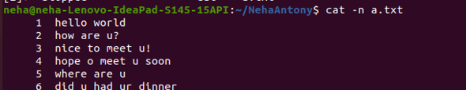

2. cat -b

This command is used to remove empty lines from the file

Syntax :- $ cat -b filename.txt

Output :-



3. touch

The touch command is used to create a file. It can be anything, from an empty txt file to an empty zip file.

Syntax :- $ touch filename.txt

Output :-



4. echo

The "echo" command helps us move some data, usually text into a file. For example, if you want to create a new text file or add to an already made text file, you just need to type in, “echo hello, my name is alok >> new.txt”. You do not need to separate the spaces by using the backward slash here, because we put in two triangular brackets when we finish what we need to write.

Syntax :- $ head filename.txt

Output :-



5. head

This command is used to display the first N number of lines

Syntax :- $ head filename.txt

Output :-



6. head -4

This command is used to display the first 4 number of lines

Syntax :- $ head -4 filename.txt

Output:-



7. tail

This command is used to display the last N number of lines

Syntax :- $tail filename.txt

Output :-

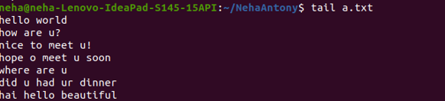

8. cut -d- -f1

**. -f (field):** **-c** option is useful for fixed-length lines. Most unix files doesn’t have fixed-length lines. To extract the useful information you need to cut by fields rather than columns. List of the fields number specified must be separated by comma. Ranges are not described with -f option. **cut**uses **tab**as a default field delimiter but can also work with other delimiter by using **-d** option.

Syntax :- $ cut -d- -f1 filename.txt

Output :-

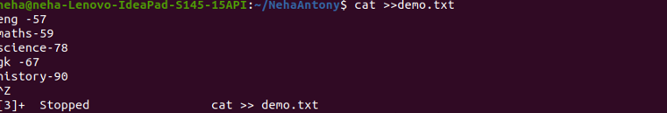

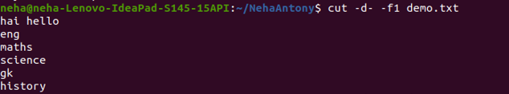

9. cut -d- -f2

This command is used to display files in the last modified order.

Syntax :- $ cut -d- -f2 filename.txt

Output :-

